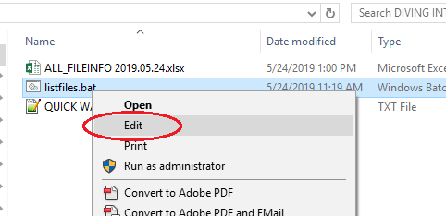

1) **RIGHT**-Click *listfiles.bat*,

**LEFT**-click on **EDIT**,

(If prompted, Open w/ **Notepad**).

2) **Change the letter-drive**

from **p:** to desired **drive** or **directory** (e.g. **“o:\TCO_CO”**)

*(NOTE: directories with many files will take a while –*

*It also depends on the health of the network).*

*For example…*

From cd /D **p:**

To cd /D **“o:/002 Project Log”**

3) **Save** & **Close**, and

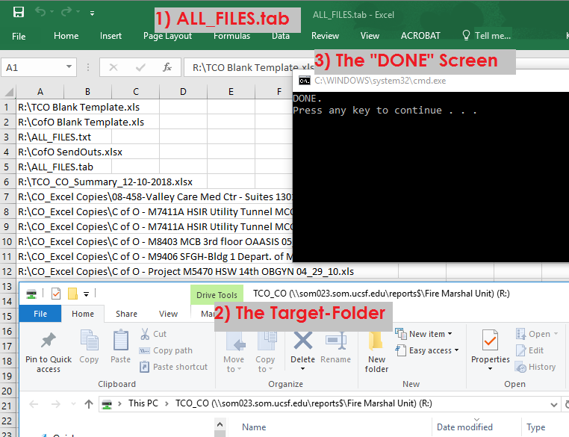**Double-Click** *listfiles.bat*.

Once the script finishes…

1. **ALL_FILES.txt** will Open
2. along w/ the **Target-Folder**
3. & A **“DONE” Screen.**

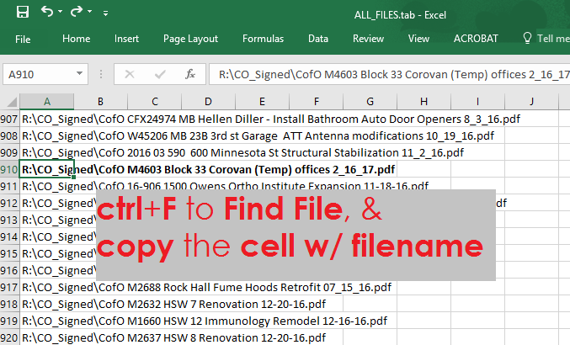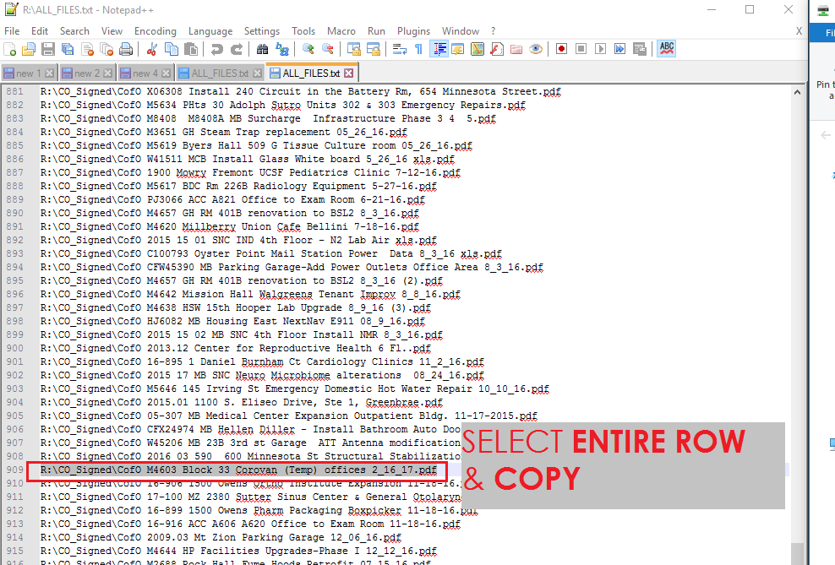

**…And…**

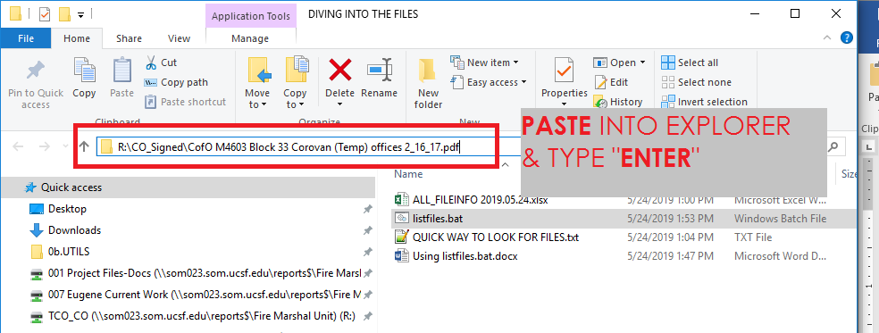

**OR…**

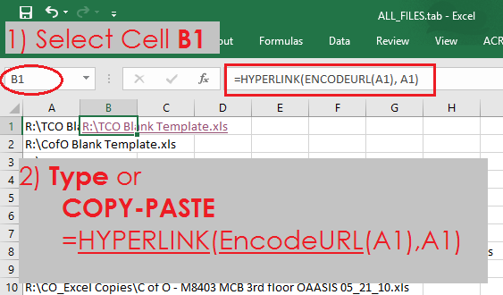

(**NOTE: EncodeURL()** helps handle *most* **Special Characters**)

**TEST link by clicking.**

**IF** the **link works**…

1) **Copy** Cell **B1** (the one w/ the link)

2) **type** the following [arrow-key / ctrl / shift]-combination…

* **←**, *Should be @ A1*
* (HOLD) **CTRL** + **↓**, “*Bottom of Column A”*
* **→**,  *“Bottom of Column B*”
* (HOLD-BOTH) **SHIFT** + **CTRL** + **↑** *BACK up to B1*

3) **PASTE**.

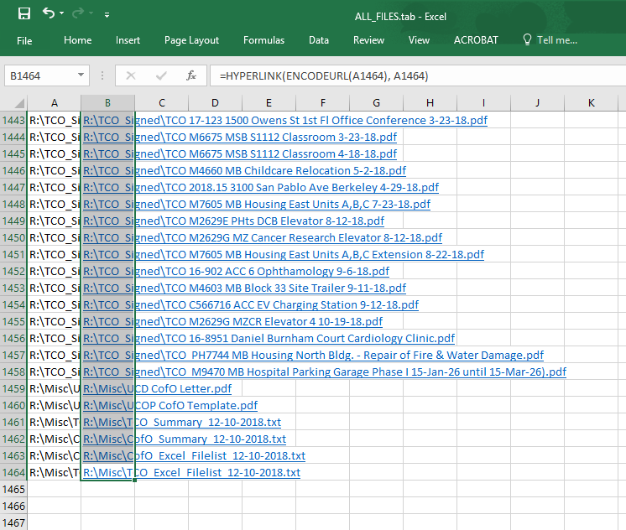

(NOTE: Some links may not work – If they don’t,

try the “Paste into Explorer” method)